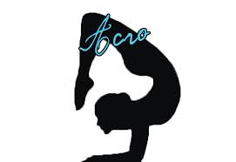Acrodance
Class Expectations: Students will learn flexibility, agility, basic floor work, strength training, balance, coordination, as well as a class like structure. Students will also focus on an acrobatic foundation to gear them toward a strong foundation for dance or any athletic sport. Students are strongly encouraged to pair this class with a ballet course to further their training.
Splits, bridges/extensions, heel stretch, scorpion, straddle stretch, chest rolls, chin stands, hand stands, cartwheels, limbers, walkovers, and floor skills, jumps, turns, leaps and balancing skills as well as turning skills will all be taught in this class as well as many other specific skills.
Class Attire Required:
Girls: Full Leotard- any color/style
No socks/tights/shoes
Studio Leo/ Shorts- Preferred

Boys: Shorts and T-shirt or Tank
No socks/shoes

**This is not a gymnastics class. You will learn basic tumbling skills used for dance, cheer and related sports.

